AIRPORT ARRIVALS
Airport Transportation will only be running for those flying into the Nashville International Airport
GREEN ROUTE

Airport Transportation
- Transportation between the airport and the Gaylord will be available and coordinated based on flight times.

- All airport arrivals will be scheduled starting Monday, April 17^{th.} Those arriving before this date will need to find their own transportation from airport to the hotel.

- Airport Transportation will be scheduled based on the flight manifest of attendee’s arrival times into the Nashville International Airport.

  - Commercial flight travelers: You should receive a copy of your e-ticket from your Carrousel Travel. If you did not, please contact your Fastenal representative. Your travel details can also be found by going to mytripandmore.com , enter the Flight Reservation Number that is found on your Summary Page of the show website.

ONCE YOU’RE PLANE LANDS:
- A Greeter holding a Fastenal sign will be at the baggage claim area to greet you. Once you retrieve your baggage the Greeter will escort you to your ride.

  - If no one is available there to help you, please call

Airport Greeter: 608-769-0021

- All buses are coded as the GREEN route and will have signage in the window.

- Travel time from the airport to the Gaylord is appx 30 minutes. Factor in the extra time it will take to retrieve luggage, board the bus, and get through traffic.

ARRIVING AT THE GAYLORD

- You will be dropped off at the Airport Depot at the Gaylord Opryland Resort. Here you will check in and find your room.

AIRPORT DEPARTURES
Delta Portico (Loading Area for Airport Departure and Evening Shuttles)
Transportation Contact: 507-458-1799
GREEN ROUTE

- Since the Convention Center and hotel rooms are all located in the same building, you can walk over to the expo anytime between 9am-4pm.

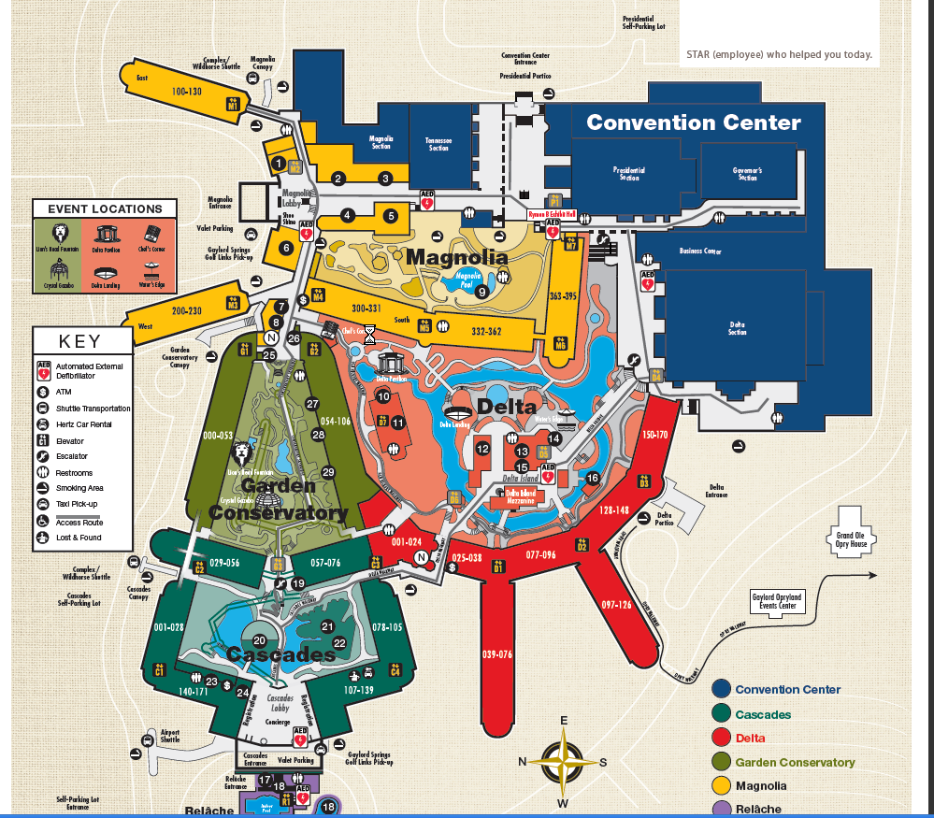

WHAT TO DO ON YOUR DEPARTURE DAY
- All attendees must be checked out of their room by 11am. DO NOT TAKE YOUR LUGGAGE TO THE FRONT CONCIERAGE DESK.

- The Gaylord will leave a note under your door which will reference how to checkout of your room. Follow these instructions.

- If you are departing between 4:00am and 8:00am – go straight to the Delta Portico to board a bus.

- If you are departing between 8:00am and 5:00pm, bring your luggage with you to the Convention Center and check it at the luggage holding station.

- Depart the convention center a minimum of 2 hours before your plane leaves. This includes the 30 minute travel time to the airport and the standard 1.5 hour check-in time recommended by the airlines. Those that do not give themselves at least 2 hours at this airport run the risk of missing their flight!

BUS LOADING TIMES FOR DEPARTURES

All Bus Departures will leave from the DELTA PORTICO (Not the front lobby!)

- Tuesday, April 18th 2:00 pm – 5:00 pm
- Wednesday, April 19th 4:00 am – 5:00 pm
- Thursday, April 20th 4:00 am – 5:00 pm
- Friday, April 21st 4:00 am – 12:00 pm

*If you do not adhere to the shuttle times listed, you will be responsible for finding your own
Evening Shuttle to Downtown Nashville
Delta Portico (Loading Area for Airport Departure and Evening Shuttles)
Transportation Contact: 507-458-1799

transportation.

SHUTTLES TO DOWNTOWN NASHVILLE

Monday, April 17th, Tuesday, April 18th, and Wednesday, April 19th

For those that would like to experience a taste of the Tennessee nightlife, we will be offering transportation to downtown Nashville. Shuttles will be staged at the DELTA PORTICO.

- 5:30pm – Shuttles begin loading. Drop off and pick will be at the Court of Flags in downtown Nashville. NOTE: There may be a wait for buses due to the number of attendees that will be boarding. Please be patient!

- 1:30pm – last shuttle will leave downtown (Court of Flags) to go back to the Gaylord.
  - If you are not on this last bus, it is up to you to find transportation back to the resort. These cab/transportation fees cannot be turned in for reimbursement.

